Action Group Extended (AGX) Manual

Mod Overview
Main Window (Selected Parts Window) in Editor.
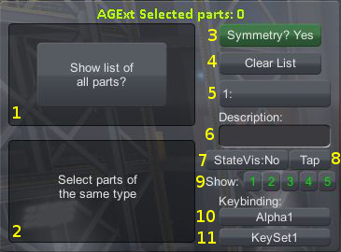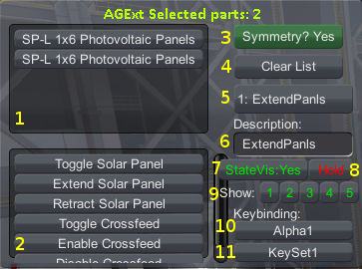
- Selected Parts List: Shows currently selected parts.
-Left: No Parts Selected, Show List of All Parts button available, click to show All Parts window.
-Right: 2 Solar Panels Selected. Click a part to remove it from the list.
- Actions List: Shows Actions available on the currently selected parts.
-Left: No parts selected, so no actions available.
-Right: Actions available on the solar panels. (Includes additional actions from other mods, note the scroll bar.) Click action to assign it to the current action group.
3) Selected parts in symmetry?
-Green (Yes): When a part is clicked in 3D game space, any parts placed in symmetry will be selected with it also.
-Red (No): When a part is clicked, only that part will be selected.
-Click to change between modes.
4) Clear List.
-Click to clear selected parts list to return window to left side state and make All Parts button available.
5) Current Group Display
-Number: The currently selected group, group 1 in these pictures.
-Text (if present): Player entered description of the group.
-Click to display Groups Window if Groups Window Auto-Hide enabled.
6) Group Description Text Box
-Text entry box where you can enter description of the current action group.
-Click to enter text entry mode, click anywhere else to leave text entry mode.
7) State Visibility: Display the state (on/off/mixed) of the action group in flight mode.
-No (gray): Display group as typical gray text in flight mode.
-Yes (green): Display group as off (Red), on (Green), or mixed (Yellow) in flight mode.
-Click to change mode for the current group.
-See State Visibility section.
8) Tap/Hold mode.
-Tap (gray): Typical key behavior, tap key to activate group.
-Hold (red): Brake key behavior, press key to activate group, release key to deactivate group.
-Click to change mode for the current group.
9) Show group in Group Visibility groups.
-Click on number to enable (green)/disable (red) the current group in that Visibility Group.
-See Group Visibility section.
10) Assigned KeyBind for the current group.
-Click to display Keybinds window.
-See the Keybinds section.
11) Assigned KeySet.
-Click to display KeySet/GroupVisibility window.
-See both the KeySets and Group Visibility sections.

Main Window in Flight Mode
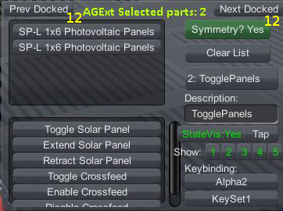
12) Prev Docked/Next Docked buttons.
-Cycle through docked Sub-Vessels on the current vessel. See the Sub-Vessel section.

Groups Window
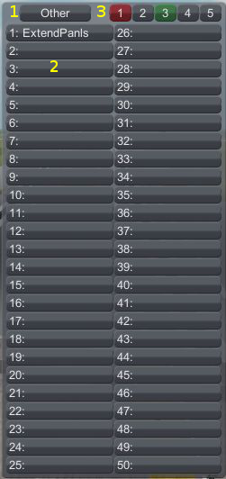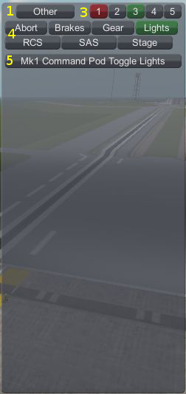
- Other button.
-Switch between Numbered Action Groups mode (left) and Named Action Groups Mode (Right).
-If in career mode and SPH/VAB is not fully upgraded, this button will not appear and only Named Actions Groups Mode will be available.
2) Numbered action groups list.
-Click on a group to change the current action group.
-A group that is green has actions assigned to it. (Not shown in current picture, to be fixed.)
3) Action groups pages.
-50 Action Groups per page.
-Red number is currently selected page.
-Green number is other page that has actions assigned, so the green 3 means that there is an action assigned in groups 101 through 150.
4) Named Action Groups list.
-Click to change the current group, current group is highlighted in green. (Not red, to be fixed.)
-There is no highlighting for other action groups with actions assigned. (To be fixed.)
5) List of actions assigned to the current named action group.
-Click an action to unassign it.

KeySets
The purpose of keysets is to make the most of your keyboard keys while avoiding conflicts. A typical use would be:
- Mothership: Uses action groups 1 through 10 for it's actions.
- Lander that docks to the mothership: Uses action groups 11 through 20 for it's actions to avoid conflicts while docked so you don't activate actions on both the mothership and lander by activating one action group.
and the keysets would be:
- Keyset 1: Bind keyboard keys 1 through 10 to action groups 1 through 10 for use while flying the mothership.
- Keyset 2: Bind keyboard keys 1 through 10 to action groups 11 through 20 for use while flying the lander.
This way, you can swap key sets with a couple mouse clicks (if fact, if you set the keyset on the lander before docking, it will remember it when you undock). By swapping the keysets, you "increase" your available keys on the keyboard you can use for actions.
KeySets are assignable to a sub-ship and change depending on which is in control and how they would work in your situation is as follows:
- KeySet1: Keys 1 through 10 activate groups 1 through 10. (Default, the keyset all your ships are currently using.)
- KeySet2: Keys 1 through 10 activate groups 11 though 20. (You would have to set this up.)
Then assign the actions you want to activate in group 3 on the first ship to group 3 and group 13 on the second ship. Then assign KeySet1 to the first ship and KeySet2 to the second ship.
Now, when you press the 3 key it activates either group 3 or 13 depending on which sub-ship has control and is automatic once you get the KeySets setup on the appropriate sub-ships.
If you want to experiment the KeySets are accessed by the button in the bottom right of the main window, it displays "KeySet1" by default as the first keyset is that.

